Magical Squaring Technique
Let us first find square of 11 using the formula: -
The formula is self-explanatory. However, let me explain it for more clarification: -
- Slash used here is just a separator.
- Our operating zone is 10 x 1 or simply 10.
- 11 is one more than 10.
- We added 1 to 11 to make it 12.
- Number of digits after the slash can be only one.
- If the number of digits after the slash exceeds one then we place only the right most digit after the slash and the remaining digits gets added to left hand side of the slash.
Will you be able to find squares of other numbers in a similar manner? Try.
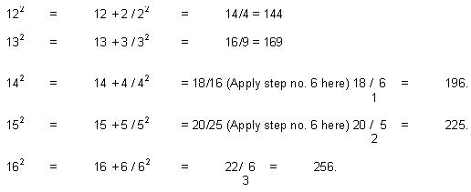
You can work like this up to 19^{2.} What about numbers above 20?
Formula remains same with a slight change. The change you will appreciate..

Magical Multiplication
Multiplication is supposedly the toughest of all four operations namely multiplication, division, addition and subtraction. Students feel threatened by multiplication.
I have covered this topic in detail.
To make this topic easily graspable, I have divided it into several parts. Each part is full of examples and steps are explained clearly wherever required. If this helps the student, I will feel rewarded.
First Formula
I have called this "First Formula" because in my opinion a person willing to learn "Magical methods of Fast calculation" should start from here. Formula will be explained by taking various examples.
Two-digit number multiplied by two-digit number.
Let us start with an example: -
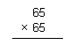
How would you multiply this in conventional way?
Let us solve it: -
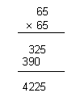
What are the steps you took here?
- First you multiplied 65 by 5 and wrote it below the line (325)
- Then you multiplied 65 by 6 and wrote it below the first row leaving one space from right (390)
- You added the numbers in first row with the numbers in the second row by first putting right most digits down and adding other digits thereafter conventionally.
- You got 4225 as answer.
Now let us do it by magical method: -
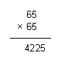
What did we do here?
- We multiplied 5 by 5 and put 25 as right hand side of the answer.
- We added 1 to the top left digit 6 to make it 7.
- We then multiplied it (7) by bottom left digit 6 and get 42; this is left hand side of the answer.
- We arrived at our desired answer 4225.
Did you get it?
Let us do some more by the method learned just now!
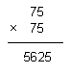
Let me explain the method again!
- We multiplied 5 by 5 and put 25 on the right hand side.
- We added 1 to the top left digit 7 to make it 8.
- We then multiplied 8 by bottom left digit 7 and kept 56 on left-hand side.
- We arrived at our desired answer 5625.
Now the method should be crystal clear to you.
In the same manner we can multiply the following: -
15 by 15, 25 by 25, 35 by 35, 45 by 45, 55 by 55, etc.
I understand, you are getting inquisitive here and planning to ask a loaded question.
Your question is whether the applicability of the formula is limited to a number ending with 5 only?
My answer is no, its not like that.
Let us expand the formula...
We can apply this formula to find multiplication of a good amount of two digit, three digit numbers.

Division
Real Magic
I am certain that you will experience thrill after learning and understanding these methods. You will find this magical. Also you will find this very easy to work with. Try to teach these methods to as many person as you can.
Denominator ending with 9
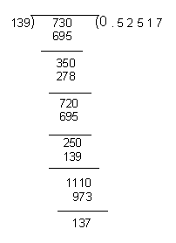
You people are well verse with conventional method so I am skipping the explanation. Now, Let us see the magical method: -
Check, whether two answers are same (?)
By conventional method our answer to 5 places of decimal is 0.52517.
By magical method also our answer is 0.52517.
There is no difference between the answers, however the procedure adopted in both the methods is different. One is more cumbersome than the other. Let me explain the steps.
Steps: -
- 73 is divided by 139 (a digit ending with 9)
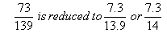
- Start dividing 73 by 14.
- Put the decimal point first, divide 73 by 14, 5 is Quotient and 3 is remainder, 5 is written after the decimal and 3 is written in front of 5 below it as shown.
- Our next gross number is 35, divide 35 by 14. Quotient = 2 and Remainder = 7. Q = 2 is written after 5 and R = 7 before 2 (below it)
- Our next gross number is 72, divide 72 by 14. Q = 5 and R = 2, Q = 5 is written after 2 and R = 2 before 5 (below it).
- Our Next gross number = 25, divide 25 by 14. Quotient = 1 and remainder = 11. Q = 1 is written after 5 and R = 11 before 1 (below it).
- We have already found answer up to four decimal places, our next dividend is 111, divide by 14. Quotient = 7, thus we have completed finding the answer up to five places of decimal.
- Repeat the above steps if you want to find the values further.
You have learned the steps required to solve such kind of problems where the denominator ends with 9. Similarly you can solve problems for denominator ending with any other digits. How?

Cube Roots
Finding Cube Roots requires some background
Background |  | Last digit
1³ = | 1 | 1
2³ = | 8 | 8
3³ = | 27 | 7
4³ = | 64 | 4
5³ = | 125 | 5
6³ = | 216 | 6
7³ = | 343 | 3
8³ = | 512 | 2
9³ = | 729 | 9
From the above illustration we can take out that last digit of 2³ is 8, 3³ is 7 and vice-versa. All other repeats itself.
Procedure of finding a cube: -
- Start from right and put a comma when three digits are over
Examples: -
9,261
1,728
32,768
175,616
- After putting the comma see the last digit of the number; compare that with table provided above. You get the last digit.
- Now see the first group of numbers and ascertain cube of which number is less than the group. That number is your first digit.
- You have thus found first digit and last digit.
Let us take an example: -
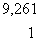
Steps: -
- Counting from last we put comma after 9.
- By seeing the last digit we ascertain that last digit of cube root will be 1.
- Now we see 9 and ascertain that 2³ = 8, is less than 9 and 3³ = 27 is more.
- Our first digit thus comes to 2, and the answer is 21.
Another Example: -
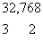
- By seeing last digit we find last digit of cube root is equal to 2.
- By seeing 32 we put 3, as our first digit as 3³ = 27 is less than 32 and 4³ = 64 is more.
- Our answer is 32.

